**Post Lab Report-02**

|  |  |
| --- | --- |
| Date: 27 March 2021 | Course: CSE345 (Digital Logic Design) |
| Experiment 2 | Id: 2019-1-60-024 |
| Name: Adri Saha | Course instructor: Touhid Ahmed |

**Experiment Name**: Design and Implementation of a Combinational Circuit

**Abstract****:** One of the introductory courses for Electrical Engineering and Electrical Engineering Technology students is logic circuit design. It can introduce students to circuit design, problem solving, testing, and feature verification. Students were asked to design some combinational logic circuits by using Karnaugh map. And they can also implement combinational circuit using AND-OR and OR-AND logic from using the K map. Here, they also find Sum of product (SOP) and Product of Sum (POS) function expressions from Karnaugh map and simplify the function. For each logic circuit, they can also learn how connect four inputs to four data switches and the output to a LED indicator. And that is how they can design a complete logic circuits and also can get to know about the uses of these. The digital logic design lab is a learning experience that most students enjoy because it gives them their first hands-on experience designing and constructing miniature structures.

**Introduction:**

**Combinational Logic Circuits**: Digital logic circuits may be combinational or sequential. A combinational circuit consists of input variables, logic gates, and output variables. The logic gates accept signals from the input and generate signals to the outputs. The principle of operation is that the circuit operates on just two voltage levels, called logic 0(low) and logic 1(high).

For n input variables, there are 2n possible combinations of binary input values.

**Uses:**

* Use in computer circuits to perform Boolean algebra on input signals and on stored data.
* Practical computer circuits normally contain a mixture of combinational and sequential logic.

**Objective**: Our main goal is to design logic circuits which produce a high (logic 1) output only when the binary number is greater than 01012 which means from index 6 the voltage will be high. Here truth tables, Karnaugh map, SOP, POS, IC’s, LED, Schematic and Structural Verilog Simulation of Combinational Logic Circuits are required to do this experiment.

* Creating a project using Quartus II software.
* Design entry using Verilog code and schematic files.
* Assigning the circuit inputs and finding specific outputs.
* Simulating the designed circuit.
* Minimize Boolean expression using k-map.
* Design a combinational circuit from descriptive problem specification.
* Implement a combinational circuit using AND-OR and OR-AND logic.

**Theory and experiments results:**

1. **Karnaugh Map:** The Karnaugh Map (in short K-map) is a special pictorial form of a truth table. This map provides a simple straightforward procedure for representation and simplification of Boolean functions. It gives simplified form to a function. So, the K-map method of solving the logical expressions is referred to as the graphical technique of simplifying Boolean expressions.

We can Simplify of Boolean expressions using Karnaugh Map by

* Define the given expression in its canonical form.
* Create the K-map by entering 1 to each product-term into the K-map cell and fill the remaining cells with zeros.
* Form the groups by considering each one in the K-map.
* Each group should have the largest number of 'ones'. A group cannot contain an empty cell or cell that contains 0
* In a group, there is a total of 2n number of ones. Here, n=0, 1, 2, …n.
* **Example:** 20=1, 21=2, 22=4, 23=8, or 24=16.

**Uses:**

* Truth tables are translated into Karnaugh maps, which offer a visual representation of a much simpler formula for expressing the same logic. However, once anyone construct a truth table, he/she can and should create a K-Map to simplify the logic.
* Karnaugh maps are used to simplify real-world logic specifications so they can be implemented with the minimum possible logic gates.
* The Quine–McCluskey method is a tabular method that outperforms Karnaugh maps when there are a lot of inputs.

1. **SOP & POS:** The methods for deducing a particular logic function are SOP (Sum of Product) and POS (Product of Sum). In other words, these are the different ways to represent the reduced logic function that has been deduced. The deduced logic function can be used to build a logic circuit.
2. **Sum of Product (SOP):** In Karnaugh Map, when we find simplified function of SOP we take the high voltage or output 1 from K-map. For SOP we put 1's in blocks of K-map respective to the minterms (0's elsewhere).
3. **Product of Sum (POS):** In Karnaugh Map, when we find simplified function of SOP we take the low voltage or output 0 from K-map. For POS we put 0's in blocks of **K-map** respective to the maxterms(1's elsewhere)

**Uses:**

* The methods for deducing a particular logic function are SOP (Sum of Product) and POS (Product of Sum). In other words, these are the different ways to represent the reduced logic function that has been deduced.
* The deduced logic function can be used to build a logic circuit.

1. **AND-OR Logic gates:** From given problem’s K-map for SOP, we get AND-OR logic expression for function of Sum of Product. The expression is here: A+BC. Here, B & C inputs relate to and gate. And then B C & A relate to OR logic gate in the output.
2. **OR-AND logic gates:** On the other hand,from given problem’s K-map for POS, we get OR-AND logic expression for function of Product of Sum. The expression is here: (A+B) (A+C). Here, A & B inputs relate to OR gate. And then B & C relate to OR logic gate. Then (A+B) & (B+C) are related to and gate to the output. So, here it is the OR-AND logic expression.

**Truth Table:**

Here, inputs are A, B, C, D(4 bit binary number) and output is F where A is the MSB and D is the LSB>The output is high (logic 1) output only when the binary number is greater than 01012.

|  |  |  |  |  |
| --- | --- | --- | --- | --- |
| A | B | C | D | F |
| 0 | 0 | 0 | 0 | 0 |
| 0 | 0 | 0 | 1 | 0 |
| 0 | 0 | 1 | 0 | 0 |
| 0 | 0 | 1 | 1 | 0 |
| 0 | 1 | 0 | 0 | 0 |
| 0 | 1 | 0 | 1 | 0 |
| 0 | 1 | 1 | 0 | 1 |
| 0 | 1 | 1 | 1 | 1 |
| 1 | 0 | 0 | 0 | 1 |
| 1 | 0 | 0 | 1 | 1 |
| 1 | 0 | 1 | 0 | 1 |
| 1 | 0 | 1 | 1 | 1 |
| 1 | 1 | 0 | 0 | 1 |
| 1 | 1 | 0 | 1 | 1 |
| 1 | 1 | 1 | 0 | 1 |
| 1 | 1 | 1 | 1 | 1 |

**Figure 1**: Truth Table for descriptive Problem

1. **Simplified Sum of Product (POS) from Karnaugh map:**

Now, the canonical form of sum of product (SOP) can be written as,

**F1(A, B, C, D) = ∑m (6,7,8,9,10,11,12,13,14,15)**

Karnaugh Map as follows:

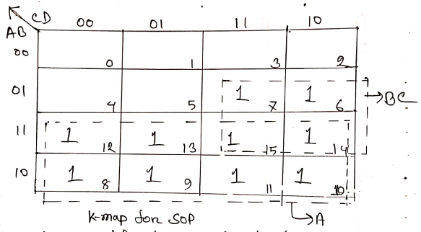

Figure 2: K-map for SOP

**1st Boolean expression is:**

**F1 = A+BC**

**Schematic Circuit**:



**Figure 3** : Logic Circuit for Simplified SOP

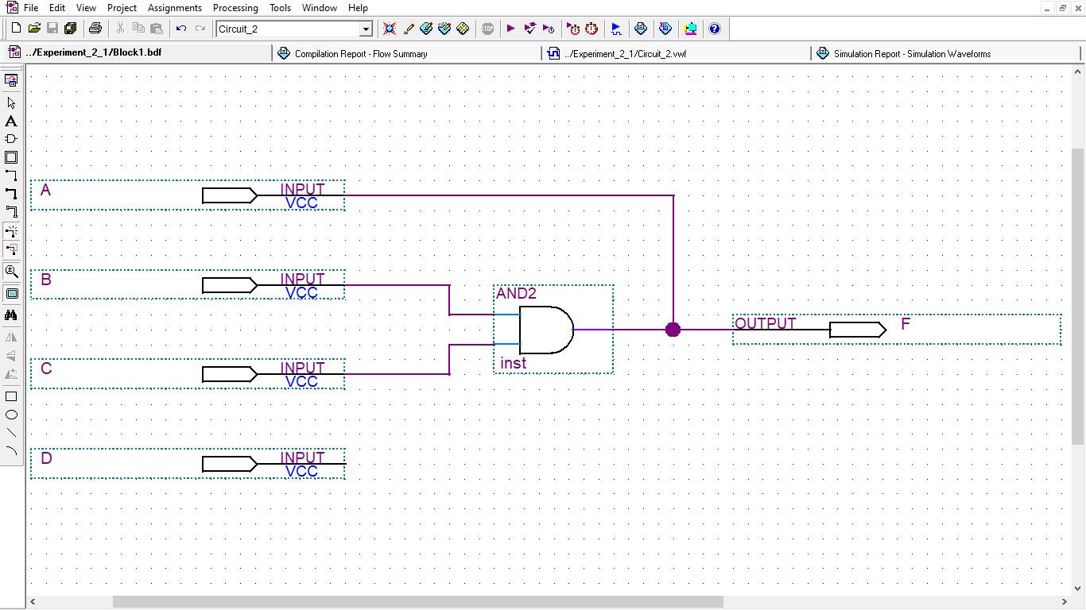

**Figure 4**: Logic Circuit for Simplified SOP Screenshot

**Schematic drawing**: This is a schematic of the design using primitive components such as logic gates, flipflops, decoders, encoders and wires for interconnections. There is a list of components in the software library that users can pick from.

**Schematic Waveform Simulation:**

In this simulation, we have taken end time 160 nano second for 4 input A,B,C,D. So, time period of A,B,C & D is 160, 80, 40 & 20 nano seconds in sequent. As there are 4 inputs.

We see, output is “high” or 1 after 60 nano seconds.

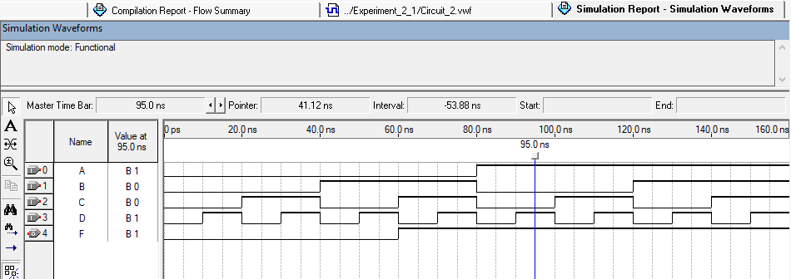

**Figure 5**: Simulated Waveform by simplified SOP logic circuit

**Verilog Codes:** Verilog is a Hardware Description Language; a textual format for describing electronic circuits and systems.

**Uses:**

* Applied to electronic design.
* Verilog is intended to be used for verification through simulation, for timing analysis, for test analysis (testability analysis and fault grading) and for logic synthesis.

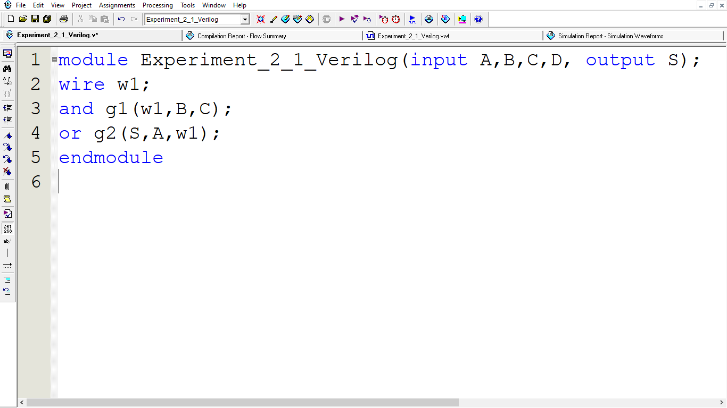

**Figure 6**: Verilog Codes for Simplified SOP

**Verilog simulation:** 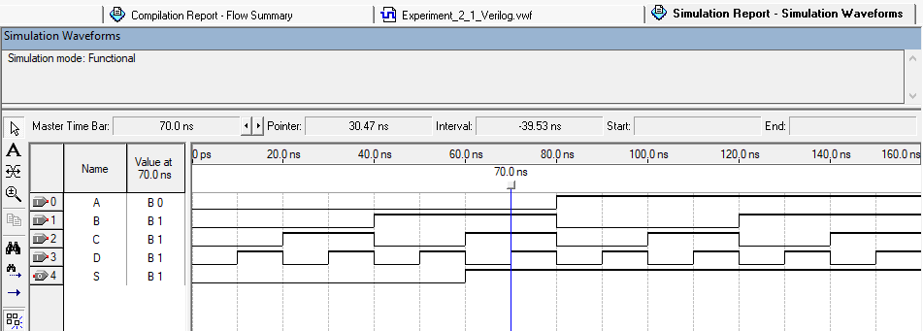

Figure 7: Verilog Codes simulation for Simplified SOP

1. **Simplified Product of Sum(SOP) from Karnaugh map:** The canonical form of product of sum can be written as,

2nd expression:

**F2(A, B, C, D) = ∑M (0,1,2,3,4,5)**

The Karnaugh Map is as follows:

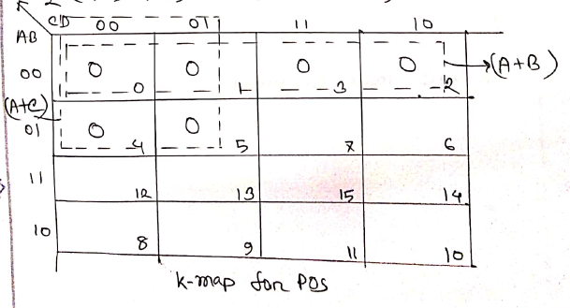

**Figure 8**: K-map for POS

The circuit diagram:



Figure 9: Logic Circuit for simplified Product of Sum function

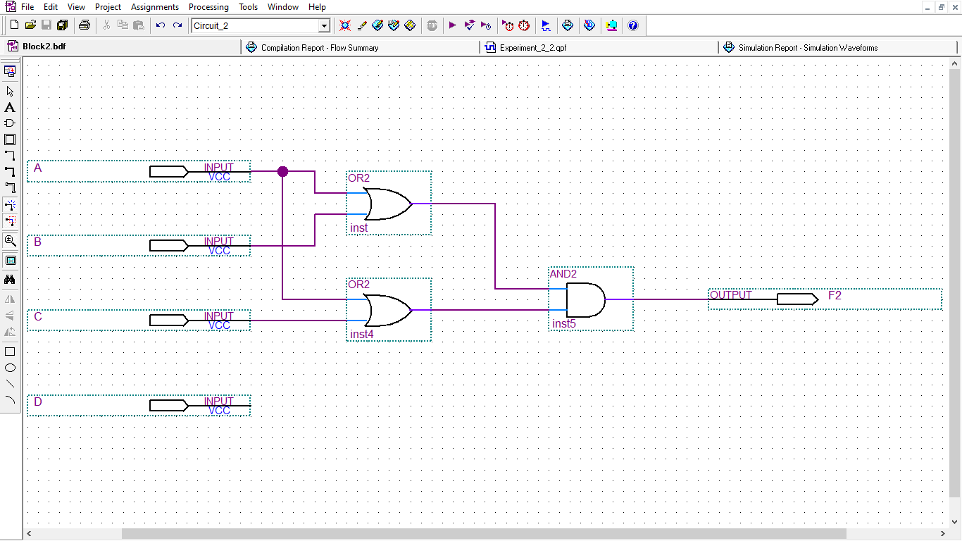

Figure 10: Logic Circuit for simplified Product of Sum function Screenshot

**Simulation**: In this simulation, we have taken end time 160 nano second for 4 input A, B, C, D. So, time period of A, B, C & D is 160, 80, 40 & 20 nano seconds in sequent. As there are 4 inputs.

We see, output is “high” or 1 after 60 nano seconds.

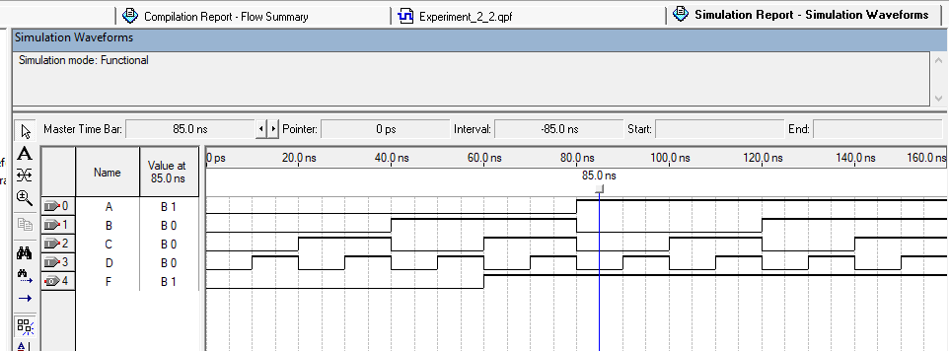

Figure 11: Simulated Waveform by simplified POS logic circuit

**Verilog Codes:**

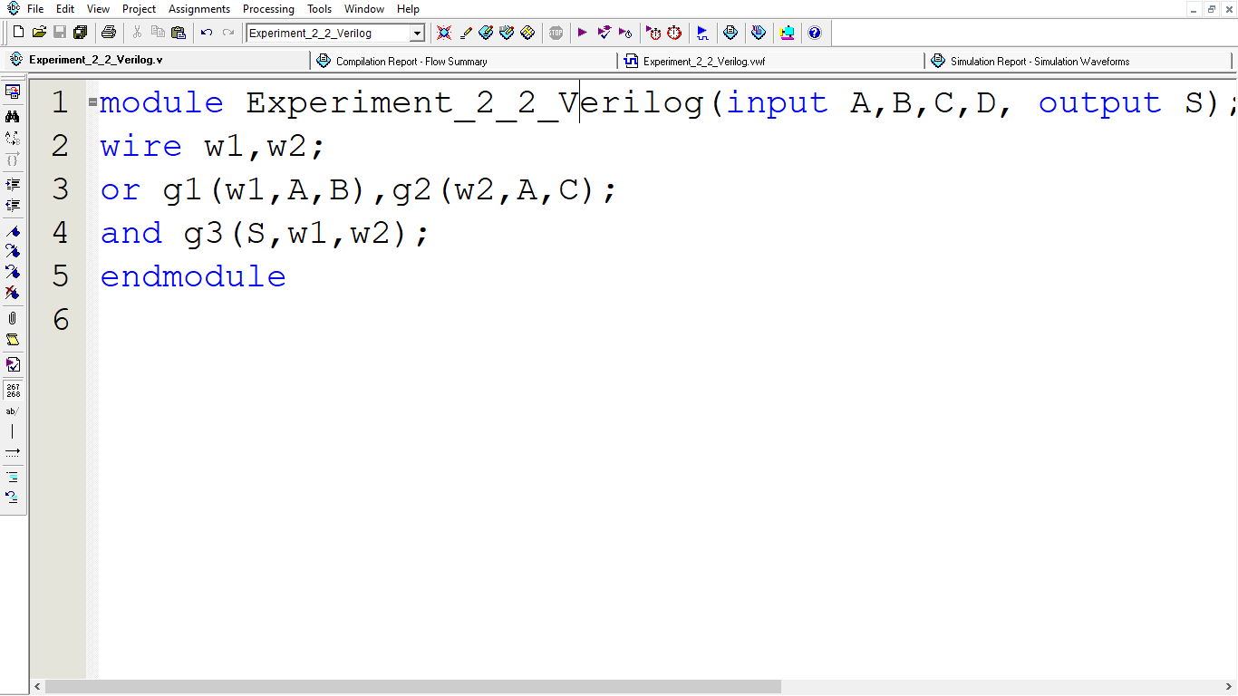

Figure 12: Verilog Codes for Simplified POS

**Verilog Simulation:**

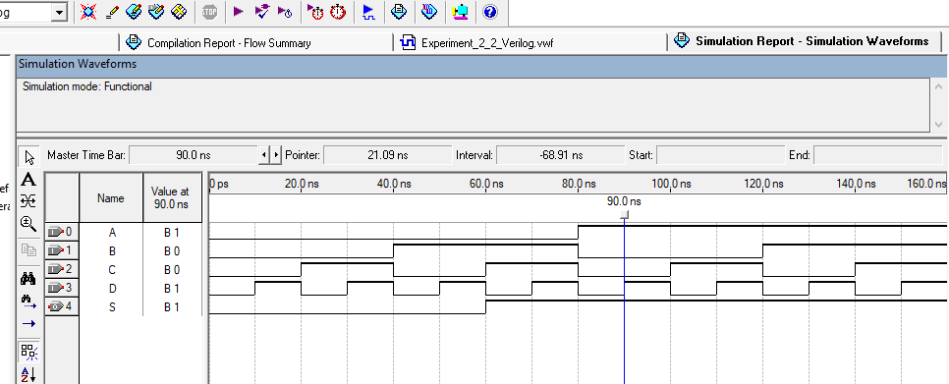

Figure 13: Verilog Codes simulation for Simplified POS

**Conclusion:** From this experiment, students learned minimizing a Boolean expression from using Karnaugh maps. They also learn to design a combinational circuit from descriptive problem specification. to verify a Boolean identity such as the distributive property truth tables are also used for Karnaugh map. They build the circuit and test the output for all simplified possible input combinations. They also know about uses of SOP & POS in Karnaugh map. And also verify his/her hands-on experience designing by Quartus Software.

**Reference:**

* Digital Logic Design; Md Mozammel Huq Azad Khan.
* https://www.javatpoint.com/simplification-of-boolean-expressions-using-karnaugh-map